Languages other than English spoken 2011
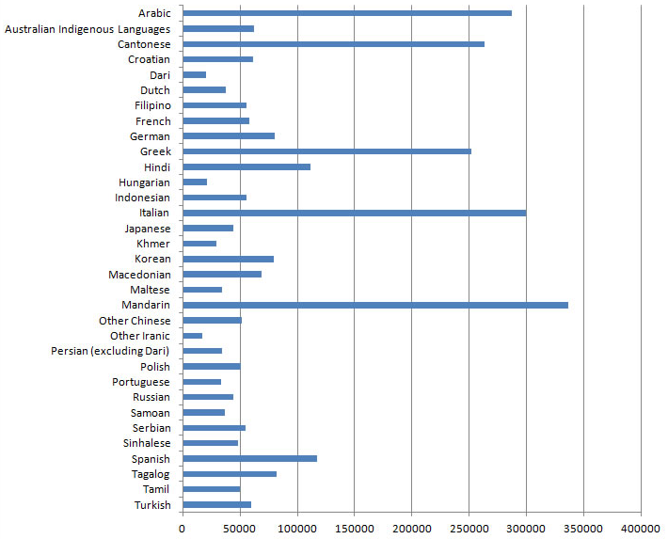
Figure 1: Source2011 Census

Chart transcript
Language | Number of people
Arabic | 287,171
Australian Indigenous Languages | 61,749
Cantonese | 263,538
Croatian | 61,545
Dari | 35,000 (rounded)
Dutch | 37,247
Filipino | 136,846
French | 57,741
German | 80,366
Greek | 252,211
Hindi | 111,349
Hungarian | 20,000 (rounded)
Indonesian | 55,861
Italian | 299,829
Japanese | 43,690
Khmer | 29,518
Korean | 79,784
Macedonian | 68,843
Maltese | 34,398
Mandarin | 336,178
Other Chinese | 51,000 (rounded)
Other Iranic | 20,000 (rounded)
Persian (excluding Dari) | 30,000 (rounded)
Polish | 50,696
Portuguese | 33,348
Russian | 44,054
Samoan | 36,574
Serbian | 55,114
Sinhalese | 48,192
Spanish | 117,493
Tagalog | 80,000(rounded)
Tamil | 50,145
Turkish | 59,625

