Indigenous languages and Australian creoles 2011
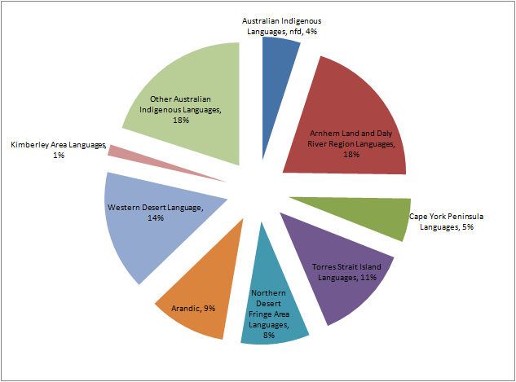

Source: ABS Census 2011

Chart transcript

Indigenous languages and Australian creoles 2011
Language | Percentage
Australian Indigenous Languages, nfd | 4%
Arnhem Land and Daly River Region Languages | 18%
Cape York Peninsular Languages | 5%
Torres Straight Island Languages | 11%
Northern Desert Fringe Area Languages | 8%
Arandic | 9%
Western Desert Language | 14%
Kimberley Area Languages | 1%
Other Australian Indigenous Languages | 18%

