Emotions Flashcards 01

Use these flashcards to identify a range of emotions that will be useful in the following slides.

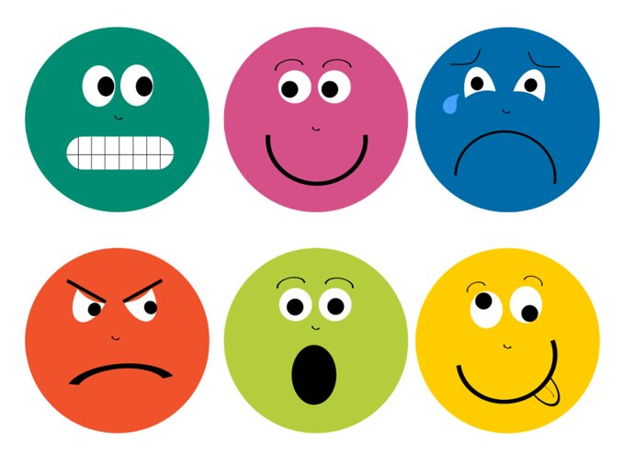  nervous | happy
sad | angry
scared | silly

Emotions Flashcards 02
Circle the face that represents the emotion written below
nervous | happy
sad | angry
scared | silly

Emotions Flashcards 03
Use the word bank to describe the emotions below
nervous  frustrated  silly | angry  sad  upset | worried  calm  scared | happy  excited  unwell

______________________ | ______________________
______________________ | ______________________
______________________ | ______________________

